**Cab Service Recommendation System Design with Azure - A Data Engineering Perspective 🚖**

Imagine you open a cab-hailing app, and instead of manually entering your pickup and drop locations, you get **smart recommendations** based on your past rides. This enhances user experience and speeds up the booking process.

**Design a cab location recommendation system** from a **data engineering perspective**. Here’s the challenge:

**Problem Statement**

**Design a recommendation engine** that suggests **10 ride locations** for a user based on their **historical ride data**. The recommendations should be:  
✅ **Personalized** – Based on the user’s ride history.  
✅ **Dynamic** – Changing based on **weekdays vs. weekends**, **time of day**, or **special ride patterns**.  
✅ **Efficient** – The recommendations table should be **updated daily**, ensuring fresh and relevant results.

**Key Considerations:**

**🔹 How should we store and process ride history efficiently?  
🔹 What should be the architecture to handle millions of rides per day?  
🔹 Which technologies best fit real-time and batch processing needs?  
🔹 How do we optimize for scale, given the high volume of users?**

This is an exciting **data engineering and system design challenge**, touching on **ETL pipelines, batch processing, real-time analytics, and scalable storage solutions**.

The challenge lies in designing a **scalable and efficient architecture** that processes millions of rides daily while keeping recommendations **accurate, timely, and responsive**. Azure provides a robust ecosystem to achieve this, combining **real-time ingestion, large-scale processing, and fast retrieval** to power intelligent recommendations.

**Capturing and Storing Ride Data Efficiently**

Every ride booked through the application generates valuable data. This data needs to be captured in real-time and stored in a way that supports **efficient querying and processing**. The system begins by ingesting ride details through an API, which sends them to **Azure Event Hubs**. From there, **Azure Stream Analytics** processes the incoming stream and writes structured data to **Azure SQL Database**, ensuring high availability and fast transactions.

To optimize performance, data is **partitioned by date**, allowing daily processing without scanning unnecessary records. This approach significantly reduces query time and supports the high volume of rides being recorded.

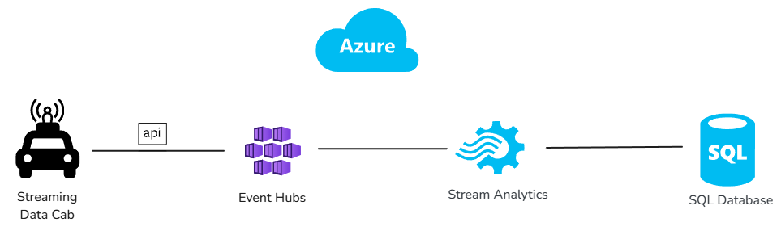

**Processing Data for Personalized Recommendations**

Generating meaningful ride recommendations requires analyzing historical travel patterns. Each ride is classified based on factors such as **time of day, day of the week, and frequency of travel**. Categories like **weekday commute, weekend leisure, and nightlife travel** help determine which rides are most relevant at different times.

Processing is done using **Azure Databricks**, where a **PySpark script** reads the day’s ride data from **Azure SQL Database**, aggregates ride patterns, and ranks locations based on historical usage. Instead of updating recommendations after every ride, the system **refreshes the recommendation table once a day**, ensuring that users receive new suggestions based on their most recent activity.

The recommendations table stores only the **top 10 most relevant destinations** for each user. Older recommendations are replaced if new travel patterns emerge, keeping the system dynamic and personalized.

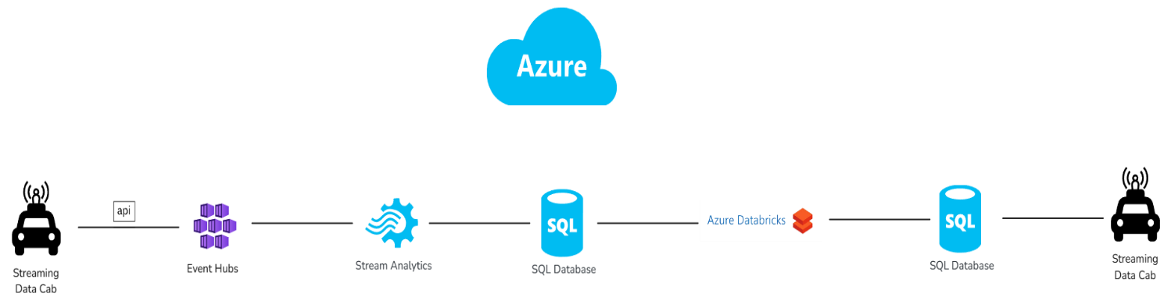

**Delivering Fast and Context-Aware Recommendations**

When a user opens the app, recommendations must be **retrieved instantly**. The application fetches suggestions from **Azure SQL Database**, filtering results based on the **current location and time of day**. Commute-related recommendations, for instance, are omitted on weekends, while leisure spots may take priority.

This precomputed approach ensures that recommendations are delivered with minimal latency. By eliminating the need for **real-time computation**, the system enhances speed while maintaining accuracy. Users see relevant destinations **instantly below the search bar**, improving their experience by reducing the effort needed to find frequent ride locations.

**Scaling for High Volume and Performance**

With millions of daily transactions, performance and scalability remain key considerations. **Partitioning strategies**, **efficient indexing**, and **distributed computing on Azure Databricks** enable the system to handle large-scale processing efficiently. Storing recommendations separately from raw ride data ensures **faster query execution**, while caching techniques further optimize response times for the application.

By leveraging Azure’s **end-to-end data pipeline**, the recommendation system remains scalable, responsive, and aligned with user behavior patterns. The combination of **Azure SQL Database, Databricks, and Event Hubs** creates a foundation that can evolve with increasing data loads while maintaining **real-time responsiveness**.

**Enhancing the Future of Ride Recommendations**

A well-designed recommendation system transforms how users interact with a ride-hailing app. By leveraging **historical ride data, intelligent processing, and real-time retrieval**, the system **anticipates user needs** and simplifies the booking experience.

With Azure powering the infrastructure, the system remains **scalable, efficient, and capable of handling millions of rides daily**. As user behavior evolves, refinements in the **ranking model, location classification, and personalization techniques** will further enhance the recommendation engine, driving even greater convenience and user satisfaction.

Would love to hear thoughts on this approach! How else can ride-hailing services improve the user experience with **data-driven insights**? 🚖✨

💡 **How would you approach this problem?** Would love to hear thoughts from the community!

#DataEngineering #SystemDesign #MachineLearning #CabRecommendations #BigData #ETL #InterviewQuestions